**Abstract Template of the 22nd European Workshop**

**on Molecular Beam Epitaxy (EUROMBE 2025)**

A. Author,1,* B. Author,1 and C. Author2

1Affiliation, City, Country

2 Affiliation, City, Country

*E-mail

The abstract should be original work and summarized in two pages (one page of text and one page of figures and/or tables). **The deadline of abstract submission is December 06, 2024.** Authors are encouraged to use this template for preparing the abstract. The format guidelines are as follows:

* Paper size: A4
* Margins: 2.5 cm on all sides
* Font type: “Times New Roman” and “Symbol”.
* Font size and style:
* Title – 14 points, Centered, Bold
* Author(s), Affiliation and Address, E-mail address of the corresponding author – 12 points, Centered, Plain
* Body text – 11 points, Single-spaced, Plain
* References in the text – should be written in square brackets: [1], [2, 3], [4-6] etc.
* Acknowledgments and References – 10 points, Single-spaced, Plain
* Figure and Table captions – 10 points, Plain

Only a PDF version of the abstract must be submitted online. For more information, please check the workshop website (<https://eurombe2025.sciencesconf.org>).

Note that the accepted PDF abstracts will be distributed to participants at the workshop.

[1] xxxxxxxxxxxxxxxxxxxxxxxxxxxxxxxxxxxxx

[2] xxxxxxxxxxxxxxxxxxxxxxxxxxxxxxxxxxxxx

The second page is reserved for figures and/or tables.

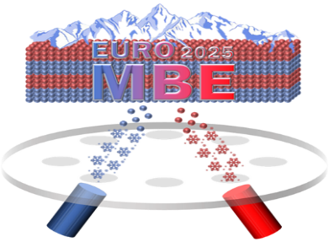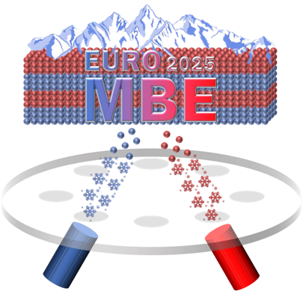

Fig. 1: Logo of EUROMBE 2025

Table I: Important dates

|  |  |
| --- | --- |
| Date | Event |
| November 28, 2024  December 06, 2024  January 10, 2025 | Registration open  Abstract submission deadline  Registration deadline |
| March 9–13, 2025 | ICMBE 2025 |